West Visayas State University
College of Information and Communications Technology
Final Project in Systems Analysis and Design: BrewCode POS
Subtitle: "Brewing Efficiency: A POS That Puts Your Café in Control"
Ryan Cabalfin, Arthur John Pagayon, Zen Anthony Pastolero, Bonn Sasana, Selwyn Tambalo
BSCS 2 - A AI

I. System Overview
System Name: BrewCode POS
Tagline: Brewing Efficiency: A POS That Puts Your Café in Control
Overview:
BrewCode POS is a user-friendly Point of Sale system designed for small to medium-sized coffee shops. It simplifies order processing, automates payment and inventory tracking, and provides real-time insights for café owners. By minimizing manual entry errors and streamlining transactions, BrewCode POS helps coffee shops run efficiently and stay in control of daily operations.

II. Preliminary Investigation
SWOT Analysis
Strengths
- Streamlines order and payment processes.
- Real-time inventory updates.
- Role-based access control.
- Designed specifically for café environments.
Weaknesses
- Limited to laptop-based POS; no mobile version.
- No integration with accounting systems.
- Excludes loyalty programs.
Opportunities
- Could expand to mobile and tablet platforms.
- Potential to integrate with delivery apps and online ordering.
- Collaboration with local café businesses.
Threats
- Competition from established POS software.
- Technological changes requiring frequent updates.
- Resistance to digital systems from traditional café staff.

III. Feasibility Study
A. Operational Feasibility
- Fully supported by the café owner.
- Staff involvement during design and testing.
- Complies with the Data Privacy Act of 2012.
B. Technical Feasibility
- Developed using Visual Studio Code, Figma, and a local SQL database.
- Runs on laptops with internet access.
- Minimum specs: Dual-core processor, 4GB RAM, 1GB storage.
C. Schedule Feasibility
- 8-week development lifecycle using the Waterfall model.
D. Economic Feasibility
- Cost-effective: ₱10,000 - ₱17,000 overall budget.
- No third-party licensing costs.
- Uses open-source tools.

IV. Software Requirements
A. Requirements Analysis
Work Breakdown Structure (WBS)

Level 1 | Level 2 |  | Level 3
1. Planning | 1.1 Requirements Gathering |  | 1.1.1 Client Interview 1.1.2 Site Analysis
2. Design | 2.1 System Design |  | 2.1.1 UI Design (Figma) 2.1.2 Database Design
3. Implementation | 3.1 Frontend Development |  | 3.1.1 POS Interface 3.1.2 User Login
 | 3.2 Backend Development |  | 3.2.1 Order Processing Logic 3.2.2 Inventory Management
4. Testing | 4.1 Unit Testing |  | 4.1.1 Order Module 4.1.2 Inventory Module
 | 4.2 System Testing |  | 4.2.1 Integration Testing 4.2.2 Acceptance Testing
5. Deployment | 5.1 Installation |  | 5.1.1 POS Setup in Café 5.1.2 User Onboarding
6. Maintenance | 6.1 Bug Fixes |  | 6.1.1 Patch Updates 6.1.2 Support

TASK ID | DESCRIPTION | DURATION (DAYS) | PREDECESSOR
1 | Gather requirements from stakeholders (staff, management, customers) | 4 days
2 | Analyze current café workflows and technology | 3 days
3 | Define functional and non-functional requirements | 3 days | 1, 2
4 | Design system architecture and interface sketches | 4 days | 3
5 | Develop order input interface | 4 days | 4
6 | Integrate inventory management system | 4 days | 5
7 | Add and configure payment processing module | 3 days | 6
8 | Test system with real transaction scenarios | 5 days | 7
9 | Perform user acceptance testing (UAT) | 3 days | 8
10 | Deploy system and perform staff training | 4 days | 9

Gantt Chart
goods, di na lang specific nga date
Task | Week 1 | Week 2 | Week 3 | Week 4 | Week 5 | Week 6 | Week 7 | Week 8
Requirements Gathering
Design (UI & DB)
Development (Frontend)
Development (Backend)
Testing
Deployment

Task | Week 1 |  | Week 2 |  | Week 3 |  | Week 4 |  | Week 5 |  | Week 6 |  | Week 7 |  | Week 8
Requirements Gathering
Analyze Workflow
Define Requirements
Design UI
Develop Order Input
Integrate Inventory
Add Payment Module
Transaction Testing
User Test
Deploy and Train Staff

PERT Chart
sala ni
Letter | Task | Depends On | Duration (Expected)
A | Requirements Gathering | — | 3.33 days
B | UI Design | A | 3.00 days
C | Database Design | A | 2.17 days
D | Frontend Development | B | 4.00 days
E | Backend Development | C | 5.17 days
F | Testing | D, E | 3.00 days
G | Deployment | F | 2.00 days

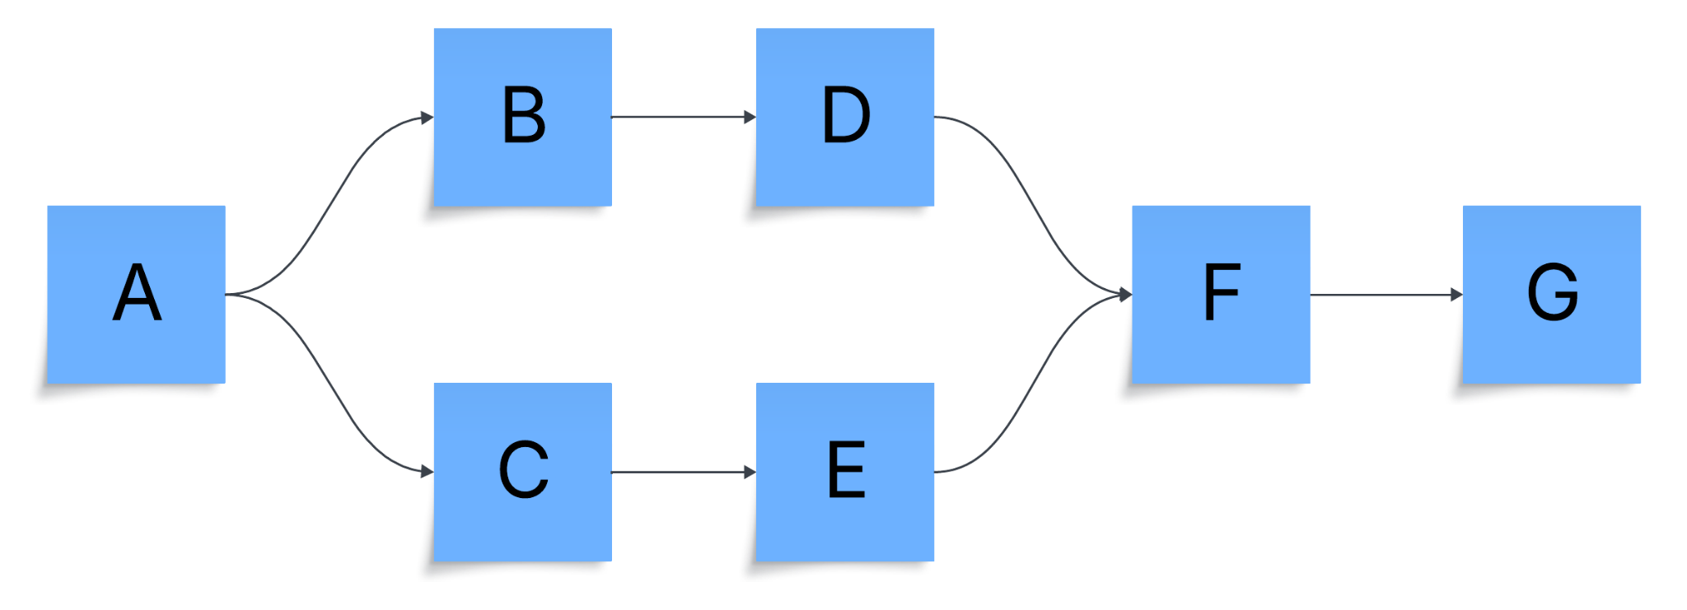

”Critical Path: A → C → E → F → G
Total Project Duration: = 15.67 days

Data Flow Diagram
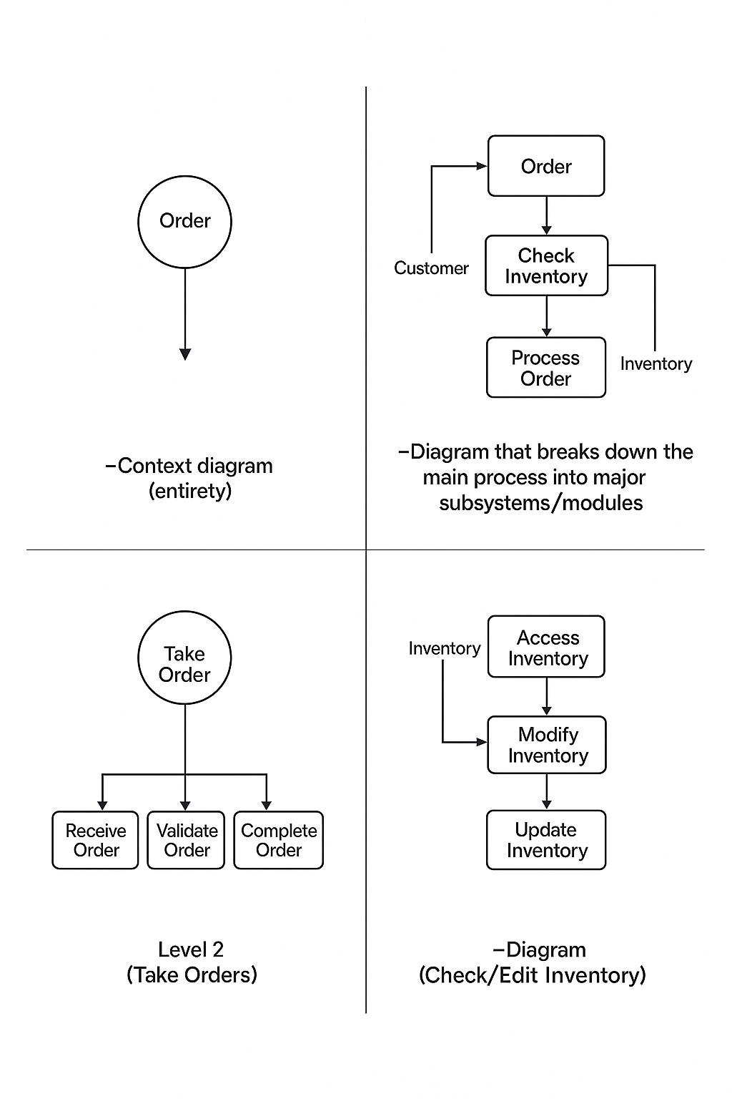


Entity Relationship Diagram
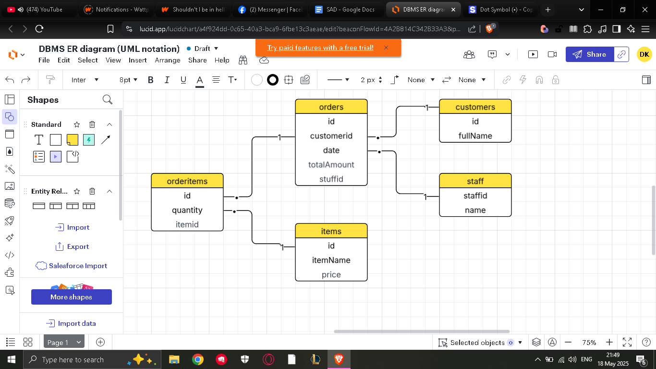
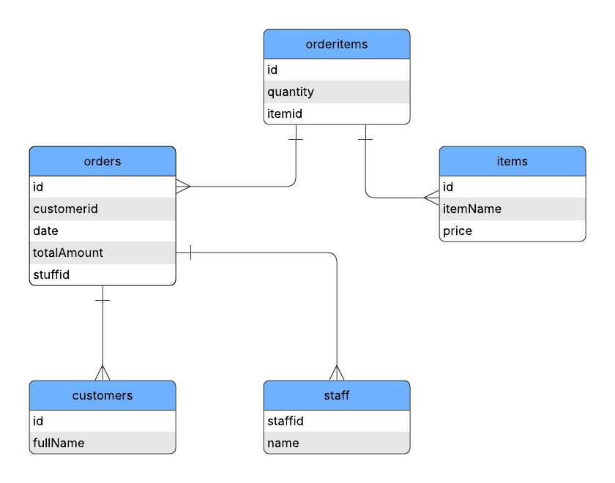

Use Case
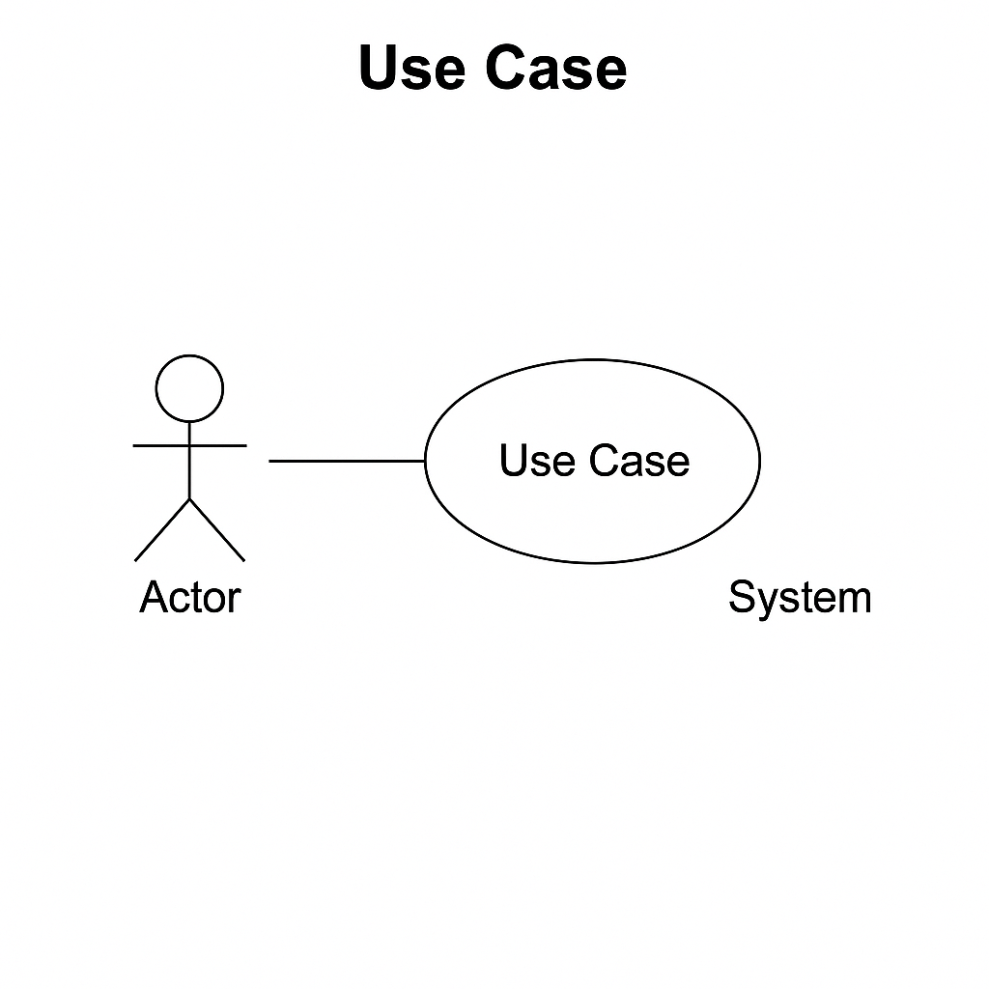
B. System Requirements
Functional Requirements
- Add, edit, and delete orders.
- View and update inventory in real-time.
- Process payments and generate receipts.
- Track order status (served/paid).
- Role-based access for owner and staff.
Non-functional Requirements
- Usability: Minimal training needed; intuitive UI.
- Security: Role-based login, secure database.
- Reliability: 99.5% uptime.
- Performance: Orders processed within 2 seconds.
- Availability: 24/7 access on café laptop.
- Scalability: Can scale to support more users if needed.
C. Conceptual and Logical Models
Data Flow Diagrams:
- Context Diagram
- Diagram 0 (High-Level View)
- Diagram 1+ (Detailed Modules)
Entity Relationship Diagram (ERD):
- Entities: User, Order, Item, Inventory, Payment
- Relationships: User-Order (1:M), Order-Item (M:M), Item-Inventory (1:1)
Class Diagram: [To be added based on ERD structure]
Use Case Diagram:
- Actors: Owner, Staff
- Use Cases: Login, Place Order, Process Payment, Manage Inventory
Flowchart:
- Illustrates flow from Home -> Order -> Payment -> Receipt
System Architecture:
- 3-tier architecture: UI layer, Logic layer, Data layer

V. Conclusion
BrewCode POS provides a practical, focused, and efficient solution tailored to small cafés. With robust functionality and minimal hardware requirements, it gives café owners greater visibility and control over operations while simplifying the workflow for staff. This documentation serves as a comprehensive blueprint for the development, implementation, and evaluation of the BrewCode POS system.

